
TUTORIAL NO: 6

Financial Accounting (FI)
Case Study
This case study explains an integrated financial accounting process in detail and thus fosters a thorough understanding of each process step and underlying SAP functionality.

Product  SAP ERP  G.B.I.  Release 6.04  Level  Undergraduate  Graduate  Beginner  Focus  Financial Accounting  Authors  Michael Boldau  Stefan Weidner  Version  2.11 | MOTIVATION  The data entry requirements in the financial accounting exercises (FI 1 through FI 10) were minimized because much of the data already existed in the SAP system. This stored data, known as master data, simplifies the processing of business transactions. Examples for this were charts of accounts and G/L accounts.  In this case study, we will create a vendor master record, process an invoice and create a payment. |  | PREREQUISITES  Before you use this case study, you should be familiar with navigation in the SAP system.  In order to successfully work through this case study, it is not necessary to have finished the FI exercises (FI 1 through FI 10). However, it is recommended.  NOTES  This case study uses the Global Bike Inc. (G.B.I.) data set, which has been created exclusively for SAP UA global curricula.


 | Process Overview
Learning Objective Understand and perform a financial accounting process. Time 65 min
Scenario In order to process a complete accounts payables process within financial accounting you will take on different roles within the GBI company. You wil be working in the Finance Account (FI) department.
Employees involved Silvia Cassano (Accounts Payable Specialist)
Shuyuan Chen (Chief Accountant)
Before you can post the account payables invoice, master data has to be maintained. Within the Case Study you will create necessary accounts within the General Ledger and create the vendor.  Afterwards you will post the invoice and verify the changes on your accounts.  Since the posting is relevant to P&L-Statement you will review the impact on your Financial Statement in the end. |  | Process description
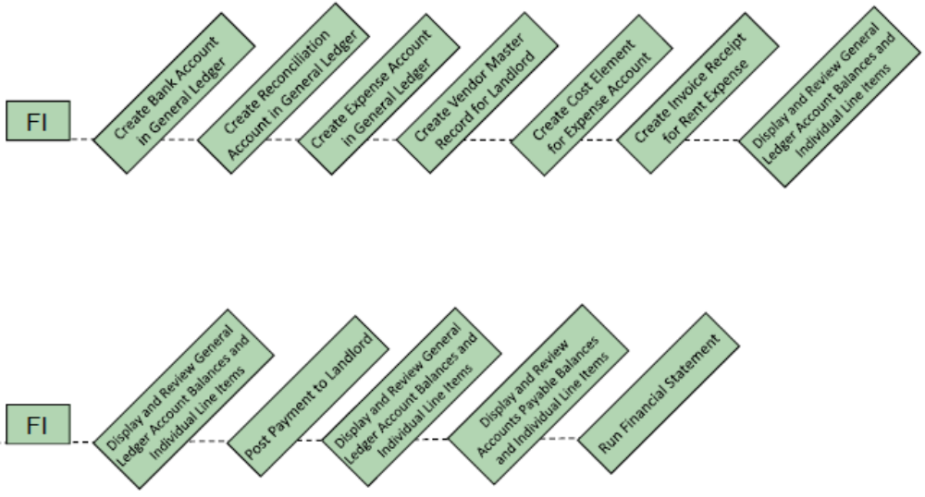

 | Create Bank Account in General Ledger
Task Create a new G/L Account. Time 5 min
Short Description Create a new Bank Account in the General Ledger.
Name (Position) Silvia Cassano (Accounts Payable Specialist)
In this case study we will create the master data that is involved in an accounts payable process and pay our rental fee as an example. We start by creating a bank account for outgoing payments to our vendor. |  | Business Scenario
To create a new account, follow the menu path:  Accounting ► Financial Accounting ► General Ledger ► Master Records ► G/L Accounts ► Individual Processing ► Centrally |  | Menu path
In the following screen, enter 10###5 (replace ### with your assigned number, e.g. 100125 if you have 012) as your G/L Account number and US00 as Company Code.  Copy data from the Bank Account 100000 in Company Code US00 by choosing G/L account ► Create with reference and entering the necessary data. Compare with the screenshot below and confirm with . |  | 10###5  US00  100000  US00
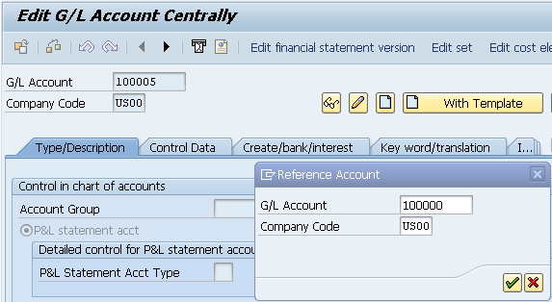
Make sure that the Account Group LA Liquid Assets is selected and the account is flagged as Balance Sheet Account.  Enter Bank ### as Short Text and Bank Account ### as G/L Acct Long Text. Again, replace ### with your assigned number. Then, click on (Save). |  | Bank ###  Bank Account ###

Your screen should look similar to the one depicted below
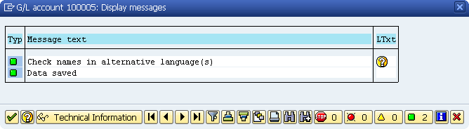
Confirm with and return to the SAP Easy Access screen using .

 | Create Reconciliation Account in General Ledger
Task Create a new G/L Account. Time 5 min
Short Description Create a new Reconciliation Account in the General Ledger.
Name (Position) Silvia Cassano (Accounts Payable Specialist)
Reconciliation Accounts connect the General Ledger with subledgers that are maintained for customers, vendors etc. Direct manual posting to the Reconciliation Accounts is not possible. Later we will create a new vendor master record and assign the new Reconciliation Account to it. |  | Business Scenario
To create a new account, follow the menu path:  Accounting ► Financial Accounting ► General Ledger ► Master Records ► G/L Accounts ► Individual Processing ► Centrally |  | Menu path
In the following screen, enter 11###5 (replace ### with your assigned number) as your G/L Account number and US00 as Company Code. Copy data from the Bank Account 300000 in Company Code US00 by choosing G/L account ► Create with reference and entering the necessary data. Confirm with . |  | 11###5  US00  300000  US00
Make sure that the Account Group RA Reconciliation Account is selected and the account is flagged as Balance Sheet Account. Enter Payables-Misc ### as Short Text and Payables-Miscellaneous ### as G/L Acct Long Text. Again, replace ### with your assigned number. Then, click on (Save). |  | ,  Payables-Misc ###  Payables-Miscellaneous ###
Your screen should look similar to the one depicted below
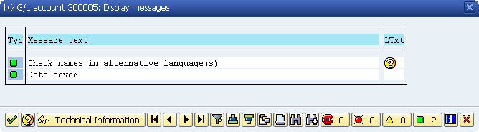
Confirm with and return to the SAP Easy Access screen using .

 | Create Expense Account in General Ledger
Task Create a new G/L Account. Time 5 min
Short Description Create a new Expense Account in the General Ledger.
Name (Position) Silvia Cassano (Accounts Payable Specialist)
To create a new account, follow the menu path:  Accounting ► Financial Accounting ► General Ledger ► Master Records ► G/L Accounts ► Individual Processing ► Centrally |  | Menu path
In the following screen, enter 75###5 (replace ### with your assigned number) as your G/L Account number and US00 as Company Code. Copy data from the Bank Account 740300 in Company Code US00 by choosing G/L account ► Create with reference and entering the necessary data. Confirm with . |  | 75###5  US00  740300  US00
Make sure that the Account Group PL Profit & Loss Accounts is selected and the account is flagged as P&L statement acct. Enter Rent Expense ### as Short Text and Rent Expense ### as G/L Acct Long Text. Again, replace ### with your assigned number. Then, click on (Save). |  | Rent Expense ###  Rent Expense ###
Confirm the following screen with and return to the SAP Easy Access screen using .

 | Create Cost Element for Expense Account
Task Create Cost Element. Time 5 min
Short Description Create Cost Element for Expense Account
Name (Position) Silvia Cassano (Accounts Payable Specialist)
For every posting to a expense or revenue account in the General Ledger a corresponding primary cost element has to exist in Management Accounting.
To create a new account, follow the menu path:  Accounting ► Controlling ► Cost Element Accounting ► Master Data ► Cost Element ► Individual Processing ► Create Primary |  | Menu path
When asked for the Controlling Area, enter NA00.  Enter 75###5 als Cost Element, choose the first of the current month as Valid From and enter Cost Element 740300 out of the NA00 Controlling Area under Reference. Compare with the screenshot below.  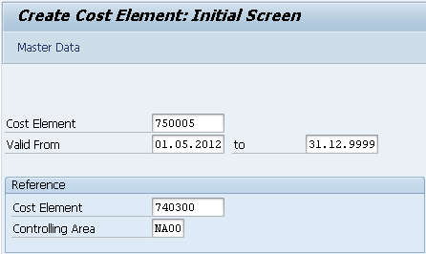  Proceed with . |  | NA00  75###5  First of the current month  740300, NA00
Enter Name Rent Expense ### and Rent Expense ## as Description.  Then, click on to save your cost element. |  | Rent Expense ###  Rent Expense ###
Return to the SAP Easy Access screen using .

 | Create Vendor Master Record for Landlord
Task Create a new vendor master record. Time 5 min
Short Description Create a new vendor for a landlord.
Name (Position) Silvia Cassano (Accounts Payable Specialist)
The Chief Financial Officer has requested you create a new vendor account for Cardinal Properties.
To create a new vendor, follow the menu path:  Accounting ► Financial Accounting ► Accounts Payable ► Master Records ► Create |  | Menu path
In the following screen, leave Vendor blank, enter Company Code US00, and Account group KRED. Enter Vendor number 105### (replace ### with your assigned number) and Company Code US00 in the Reference field.  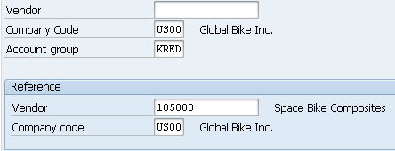  Then, click on . |  | US00  KRED  US00
In the Create Vendor: Address view, enter Cardinal Properties ### as Name, Search term ###, Postal code 55347, City Eden Prairie, Country US, Region MN under Street Address. Make sure English is selected as language and click on three times. |  | Cardinal Properties ###  ###  Eden Prairie  MN 5347, US  EN
In the Create Vendor: Accounting information Account view, enter Recon. Account 11###5 under Accounting Information. Then, click on . |  | 11###5
In the Create Vendor: Payment transactions Accounting view, enter Payt Terms 0001, and select Chk double inv. Then, click on (Save). |  | 0001  Chk double inv.
Click on the exit icon to return to the SAP Easy Access screen.

 | Create Invoice Receipt for Rent Expense
Task Create an invoice receipt. Time 5 min
Short Description Enter an invoice received from Cardinal Properties for this month’s rent of $1,500.00. This invoice will be posted to an existing G/L expense account in your chart of accounts and saved as an Accounts Payable to Cardinal Properties.
Name (Position) Silvia Cassano (Accounts Payable Specialist)
To create a invoice receipt, follow the menu path:  Accounting ► Financial accounting ► Accounts Payable ► Document entry ► Invoice |  | Menu path
Enter your vendor number for Cardinal Properties (use the F4-Help with serach term ### if necessary), today as Invoice Date, $1,500 as Amount of Invoice and Invoice HR-### as Text. Remember to replace ### with your assigned number. |  | vendor number  today  $1,500  Invoice HR-###
If your company code did not default in, select the following system menu entry:  Edit ► Set Company Code  Then, enter your company code. |  | US00
Enter your Expense Account 75###5, D/C Debit, Document amount $1,500, and Cost center NAHR2###. Then, click on . |  | 75###5  Debit  $1500  NAHR2###
Use the button to see if the postings are correct.
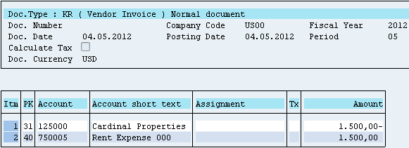
Click on to save your invoice receipt.
Click on the exit icon to return to the SAP Easy Access screen. Confirm the warning with a click on yes.

 | Display and Review General Ledger Account Balances and Individual Line Items
Task Display and review general ledger account balances. Time 5 min
Short Description Display and confirm the activity and associated balance for the rent expense account used in the previous exercise.
Name (Position) Silvia Cassano (Accounts Payable Specialist)
To display ledger account balances, follow the menu path:  Accounting ► Financial accounting ► General ledger ► Account ►  Display balances |  | Menu path
Enter Account number from 750005 to 759995, Company Code US00, and the current year as Fiscal Year. Then, click on to display balances. |  | 75###5  US00  current year
Double click on month balance to see line items. You might see multiple of the invoiced amount. Try to explain why.
____________________________________________________________
To achieve a better overview, you will remove unneeded columns from the report. Start by clicking on , select the rows shown in the picture below and click on .
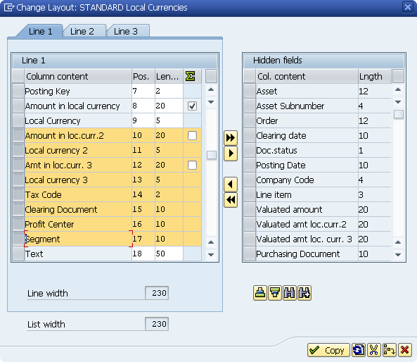
Confirm the layout change with ENTER or . The screen should look similar to the one depicted below.
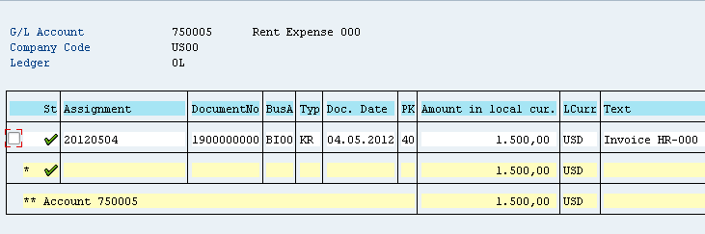
Review the entries of your document. To do so, click in the line with your invoice and press .
Keep clicking on the exit icon until you return to the SAP Easy Access screen.

 | Display and Review Accounts Payable Balances and Individual Line Items
Task Display and review Accounts Payable balances and individual line items. Time 5 min
Short Description Display and confirm the activity and associated balance for the Accounts Payable for Cardinal Properties. Note that this transaction is considered to be “open” which means that payment has not been sent to Cardinal Properties as of this time.
Name (Position) Silvia Cassano (Accounts Payable Specialist)
To display Accounts Payable balances, follow the menu path:  Accounting ► Financial accounting ► Accounts payable ► Account ►Display balances |  | Menu path
Enter your vendor number for Cardinal Properties, Company code US00, and the current year as Fiscal Year. Then, click on to display balances. |  | Vendor number  US00  current year
Double click on month balance to see line items.
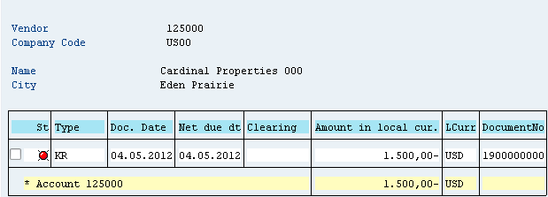
You can see that the document status is open, meaning your vendor has not been paid yet.
Click on the exit icon to return to the SAP Easy Access screen.

 | Post Payment to Landlord
Task Issue a payment to your landlord. Time 10 min
Short Description Issue a payment to Cardinal Properties to settle the Accounts Payable for this month’s rent A journal entry is made to Accounts Payable for Cardinal Properties and to the bank checking account in the G/L.
Name (Position) Silvia Cassano (Accounts Payable Specialist)
To issue a payment, follow the menu path:  Accounting ► Financial accounting ► Accounts payable ► Document entry ► Outgoing payment ► Post |  | Menu path
Enter current date as Document Date, your Bank Account 10###5, Amount 1500, and Invoice HR-### as text. |  | Current date  10###5 1500  Invoice HR-###
Under Open items selection, enter your vendor number for Cardinal Properties (use the F4 help) and leave all other settings unchanged.  Select and review the line item information. |  | Vendor number
When assignment has been made correctly the ‘Not assigned’ value on the bottom should equal $0.00.
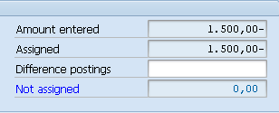
Click on to save your payment.
Click on the exit icon to return to the SAP Easy Access screen. Confirm the warning with a click on yes.

 | Display and Review General Ledger Account Balances and Individual Line Items
Task Display and review General Ledger account balances. Time 5 min
Short Description Display and confirm the activity and associated balance for the rent expense account used in the previous exercise.
Name (Position) Silvia Cassano (Accounts Payable Specialist)
To display G/L account balances, follow the menu path:  Accounting ► Financial accounting ► General ledger ► Account ►  Display balances |  | Menu path
Enter your Account number 10###5, Company Code US00, and the current year as Fiscal Year. Then, click on . |  | 10###5  US00  current year
Verify details of Document #, Type, Amount and Comments. Double click on month balance to see line items.
Click on the exit icon to return to the SAP Easy Access screen.

 | Display and Review Accounts Payable Balances and Individual Line Items
Task Display and review Accounts Payable balances. Time 5 min
Short Description Display and confirm the activity and associated balance for the Accounts Payable for Tanager Leasing, Inc.
Name (Position) Silvia Cassano (Accounts Payable Specialist)
To display Accounts Payable balances, follow the menu path:  Accounting ► Financial accounting ► Accounts payable ► Account ► Display/Change line items |  | Menu path
Enter your vendor number using the F4 help with search term ###, Company code US00, and select all items. Then, click on . |  | Search term ###  US00  all items
Verify details of Document #, Type, Amount and Comments. Notice that this display gives you a different view of the vendor account. The first column should indicate with the green square that the document is cleared.
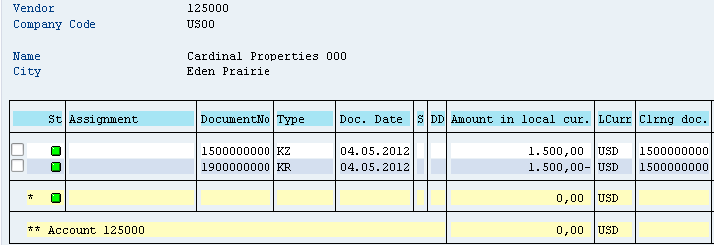
Click on the exit icon to return to the SAP Easy Access screen.

 | Run Financial Statement
Task Use the SAP menu to run a trial financial statement. Time 5 min
Short Description Run a trial financial statement.
Name (Position) Shuyuan Chen (Chief Accountant)
To view a balance sheet, follow the menu path:  Accounting ► Financial accounting ► General ledger ► Information system ► General ledger reports (new) ► Financial Statement / Cash Flow ► General ► Actual/actual comparisons ► Financial statement |  | Menu path
Enter Chart of accounts GL00, Company code US00, Financial statement Version G###, and the current year as Reporting year. Choose ALV tree control with the layout 1SAP for the list output. |  | GL00 US00  G### current year  1SAP
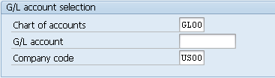
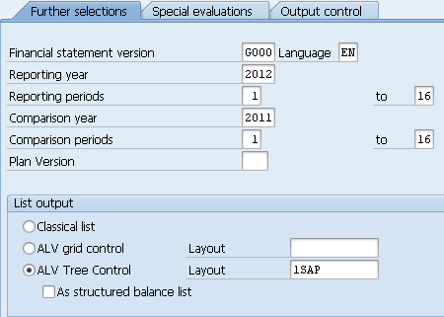
Then, click on .
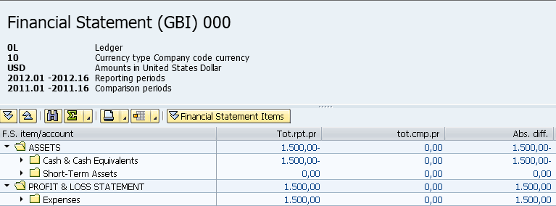
Click on the exit icon to return to the SAP Easy Access screen.

